|  |  |  |  |  |
| --- | --- | --- | --- | --- |
|  |  | |  | | --- | | WVSC Blog  November 2016 | |  | |
|  |  |  |

# **Welcome to #OurPlace**

Today, we held our first #OurPlace event, and I have to say I found it really inspirational. I never need reminding of this, but if I did, today was a reminder of the wonderful people in Wolverhampton that are doing amazing things that help people to feel valued, included and part of something special in our city.

Not to mention the outcomes they are achieving; such as improved mental and physical health and wellbeing, community cohesion, safer spaces, and so much more.

The event was about connecting, co-producing and collaboration in Wolverhampton. We have a long history of active citizenship in our city, and of working together to make it a more vibrant and inclusive place to be.

#OurPlace brought together some of the people who are at the forefront of building and nurturing community activism for social good. Sam Axtell from The City of Wolverhampton’s Economic Inclusion Team, @economicinclusion, shared information about Make:Shift @makeshiftevent ideas festival, and Maria Billington from Gatis Community @gatiscommunity introduced the latest idea from the [Eden Project](http://www.edenproject.com/): Share Fairs.

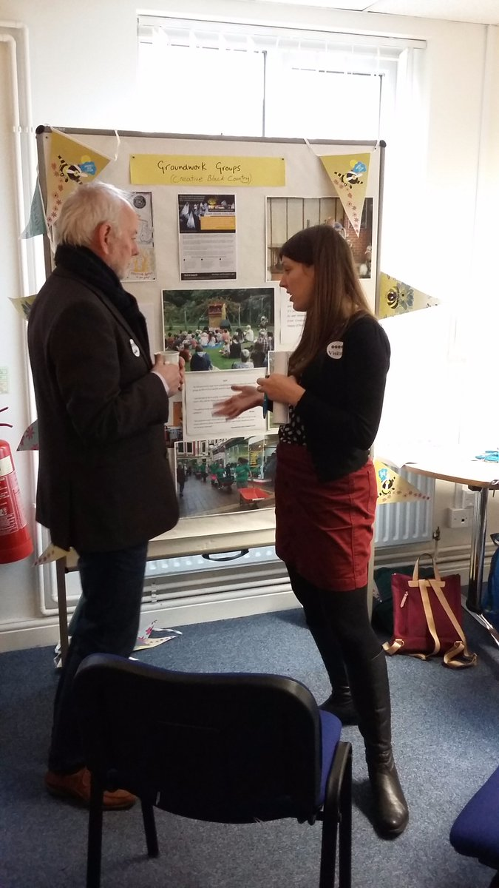

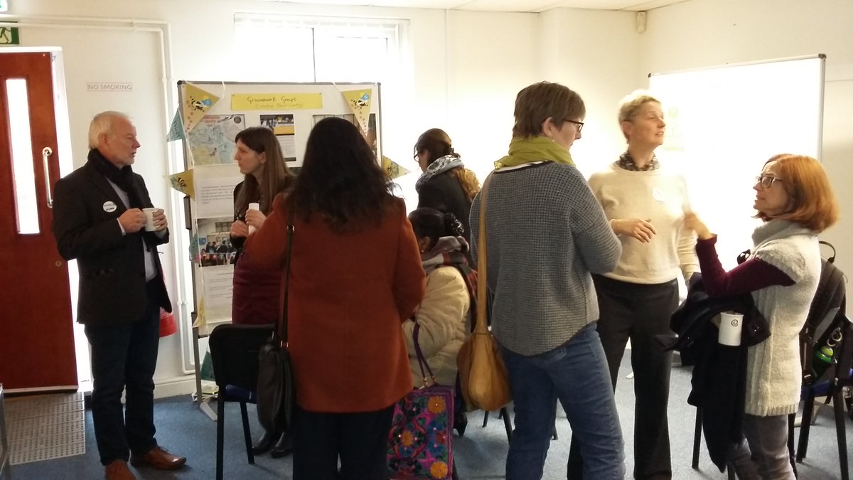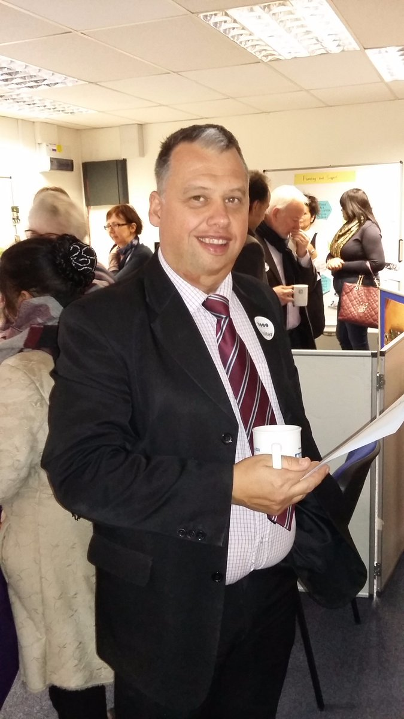

Sajida Carr and Rosalind Highet from Creative Black Country @CreativeBCuk shared information on how to become a Groundwork Group and the exciting opportunity to work with the arts for up to 12 months.

We were also pleased to welcome a recipient of the Creative Black Country Open Access funding, Arun Bector, exhibiting the work of his mental health group. Sharon Nanan-Sen from WVSC @WolvesVSC shared some suitable funding opportunities available for grassroots projects and offered top tips on successful applications.

We also shared our new Activate Pack, which builds on the work of Lorna Prescott from Dudley CVS @dosticen and @TessyBritton’s Participatory City [www.participatorycity.org](http://www.participatorycity.org).

Please follow-up some of these exciting opportunities by following the Twitter accounts and web addresses shared here.

If you want to see all the Tweets from the day, they are [here](https://storify.com/WolvesVSC/ourplace) on Storify.

So, enough of what has already happened, what next? I hear you ask. The answer is there is much to get involved with.

We will be bringing further #OurPlace events to a venue near you over the coming weeks and months. These events are an opportunity for people of all ages to come along to find out more, be inspired by imaginative projects from around the world, and importantly connect with people who share their passion, or want to dedicate their time and energies to helping others. Together, we hope that we will all learn, share and build creative solutions to issues that affect us in our neighbourhoods across Wolverhampton.

People who want to start projects will be supported to build their teams, design their project and test their ideas, and where appropriate, to access funding and/or support to take their project forward.

Although not all projects require funding, West Midlands Police and WVSC are working in partnership to run these events to encourage people to get actively involved in projects in their local neighbourhoods, encouraging them to make a positive difference to their communities. WVSC will work with people to develop their projects and apply to the Active Citizens Fund, along with other funding opportunities that may be available to them.

We look forward to meeting with you, and working together on an array of exciting new collaborative projects.

Follow our social media accounts and sign up to our website for information about further #OurPlace events.

**Saffi Price, Deputy Chief Executive – Operations.**

