v 0.2

Patient & Public Voice (PPV)

Application Information Pack

Contents

1. Introduction 3
2. How to apply 3
3. Diversity and equality of opportunity 3
4. Once we receive your application 4
5. Background, context and aims of the programme 4
6. Role of the group / committee 5
7. Importance of PPV partners 5
8. What is the role of PPV partners on the group 5
9. Skills and experience are required for this role 6
10. Time commitment 6
11. Support for PPV partners 7

A guide on how to apply to become a PPV partner of

The National End of Life Care programme board

Introduction
Please read this application information pack before completing the application form, to ensure you fully understand the application process, and to determine whether you have the skills and time to become a PPV partner.

Please note the closing date for applications is 24 February 2017.

NHS England will reimburse all reasonable expenses incurred by the PPV partner for attending the programme board meetings, as well as provide an involvement payment of £150 per meeting. Please note involvement payments must be declared to HMRC and the Job Centre, and may affect receipt of state benefits/insurance policy payments. If this applies to you, please seek advice before applying.

Please note that correspondence will be primarily via email, unless otherwise requested. If you do not have access to email and would like to be contacted via phone call or post, please state this on your application form.

How to apply
Accompanying documents that you need to complete and return include:

- Application Form
- Equality Opportunity Monitoring Form

You can either return these documents by email Emily.walton3@nhs.net or alternatively by post Emily Walton, 5W23, NHS England, Quarry House, Quarry Hill, Leeds, LS2 7UE.

To receive other formats of this Application Pack (e.g. easy read version) please contact Emily.walton3@nhs.net

We will rely on the information you provide in the Application Form to assess whether you have the skills and experience required for this position.

Diversity and equality of opportunity
NHS England values and promotes diversity and is committed to equality of opportunity for all. To help us understand if we are achieving this, we ask you to fill out an Equal Opportunity Monitoring Form as part of the application process.

We also ask you to let us know if you have special needs that we need to support to enable you to participate fully.

Once we receive your application
The steps will be as follows:

- We will acknowledge receipt of your Application Form via email (unless otherwise specified). If you do not receive an acknowledgement within 5 days, please get in touch.

- Applications will be shortlisted by a panel, including members drawn from the following groups: NHS England, The National Council for Palliative Care and Dying Matters, Gloucestershire Clinical Commissioning Group.

- Applications will be assessed against the skills and experience required, outlined in section 9 below. Selection will be made on the basis of the content of the application form.

- Interviews will take place week commencing 6 March 2017 and will be conducted via teleconferencing.

- Please note that two references will be taken up for successful applicants before involvement can commence.

- All applications will receive a successful or unsuccessful notification. The successful notifications will include information about next steps.

If you wish to be informed about future involvement opportunities with NHS England, there is an option on the Application Form to select.

If you have any queries about the application process, or would like an informal discussion about the opportunity – please contact Emily.walton3@nhs.net

Background, context and aims of the programme
The national End of Life Care Programme aims to deliver a number of objectives:

- Embed the Ambitions for Palliative and End of Life Care: A national framework for local action 2015-2020
- Deliver the government’s response to the ‘Choice Review’ including the six point ‘End of Life Care Commitment’
- Deliver the NHS England Mandate objective that by 2020 we should “significantly improve patient choice, including in maternity, end-of-life care and for people with long-term conditions, including ensuring an increase in the number of people able to die in the place of their choice, including at home”.

To support achievement of these objectives NHS England is proposing to lead the EoLC programme through cross-system governance, supporting commissioners and providers through three workstreams, to:

1. Enhancing physical and mental well-being of the individual
- To optimise the person’s mental and physical wellbeing so that they can ‘live as well as they wish’ until they die
- To optimise support for their families, carers and those important to them to maximise their wellbeing before and after the person’s death

2. Transforming experience of end of life care in hospitals and the community
- To significantly improve the experience of end of life care in hospitals, at home, and in care homes, hospices and other institutions

3. Commissioning quality services that are accessible to all when needed
- To support commissioners and service providers to design and implement models of care which promote integration and care that feels coordinated to those using, and delivering, end of life care

The work of the programme board is supported and influenced by the national ‘Ambitions Partnership for Palliative and End of Life Care’, a partnership of 27 statutory and voluntary organisations who collectively produced the ‘Ambitions framework for palliative and end of life care: National framework for local action’. The partnership is represented by two members on the board who represent the views of their members and consider how they can support the board to deliver its objectives.

Role of the group / committee
The purpose of the End of Life Care Programme Board is to ensure and support progress against the three end of life care work streams. This includes to:

- Provide accountability, challenge and assurance of programme delivery
- Ensure coherence and a common sense of direction across the three work streams
- Identify where further work, within or across individual work streams might be needed to achieve the government’s response to the Choice Review, NHS Mandate and Ambitions for Palliative and End of Life Care: A national framework local action 2015-2020, and to commission work accordingly
- Identify synergies between individual projects and recommend changed or additional deliverables to help exploit these with programme board members and other Arm’s Length Bodies, individual project groups, voluntary sector organisations
- Identify and manage high-level risks to delivery
- Be accountable for the project’s expenditure

The National End of Life Care programme board terms of reference can be found in annex 1.

Importance of PPV partners
NHS England is committed to ensuring that public and patient voices are at the centre of shaping our healthcare services. Every level of our commissioning system needs to be informed by insightful methods of listening to those who use and care about our services. Their views should inform service development.

What is the role of PPV partners on the group?
PPV representation will bring important views, perspective and challenge into the National End of Life Care programme board. This role is essential in championing a service user, patient and/or carer/family viewpoint, ensuring that the needs of them are met through the outcomes of the programme.

The role of the PPV partner is to:

- Champion the diversity of PPV views, and not just to represent their own experience.
- Provide some critical friend challenge into the group.
- Champion and advocate for increasing patient and public awareness of the programme’s outcomes and achievements.
- Review programme plans and other associated documentation.
- Channel wider EoLC networks/forums to share learning and gather insight.
- Comply with the Standards of Conduct, respecting the confidential nature of discussions when it is made clear by the Chair that this is a requirement.

Skills and experience are required for this role
To enable a broad range of views, The National End of Life Care programme board are looking to recruit two types of individuals:
- An individual living with a terminal illness
- A carer of someone living with a terminal illness, including a bereaved carer.
The individual must possess the following skills and experience:
- Interest in improving End of Life Care experience and services.
- Experience of End of Life Care, either as a patient or carer.
- Experience of speaking in large groups.
- Interacting with multiple stakeholders at senior management level.
- Ability to understand and evaluate a range of information and evidence.
- Experience of working in partnership with healthcare organisations or programmes.
- Ability to display sound judgement and objectivity.
- Have an awareness of, and commitment to, equality and diversity.
- Understand the need for confidentiality.

Time commitment
- Membership of the programme board is for 12 months initially, at which point membership will be reviewed.
- You will be required to attend meetings approximately every 8 weeks.
- Meetings will normally last for 2 hours.
- PPV partners will be expected to show some commitment outside of the regular board meetings to channel wider EoLC networks/forums to share learning and gather insight.

Support for PPV partners
- An induction session will take place, at which point a named link will be provided to support PPV partners with information they may require. Other support includes:
- Meeting documents, and if necessary, pre-meeting briefings will be provided.
- Reimbursement of out of pocket expenses incurred in line with NHS England’s PPV Expenses Policy. Expenses usually cover travel, accommodation and/or any subsistence requirements that arise. PPV partners should highlight within their application form any barriers to participation, for example, the costs of a carer that may need to accompany a PPV representative. Please get in touch with your named contact (or email england.nhs.participation@nhs.net) to discuss any support requirements that you might have.
- Provision of a £150 involvement payment per meeting will be paid to the PPV partner. Please note these payments have to be declared to HMRC and the Job Centre. Please contact: Bedford Citizen Advice Bureau involve@bedfordcab.org.uk / 01234 330604 to get expert advice. This may affect receipt of state benefits or any insurance policies you may have. There is always the option of no payment or part payment if necessary, dependent on your payment limits.

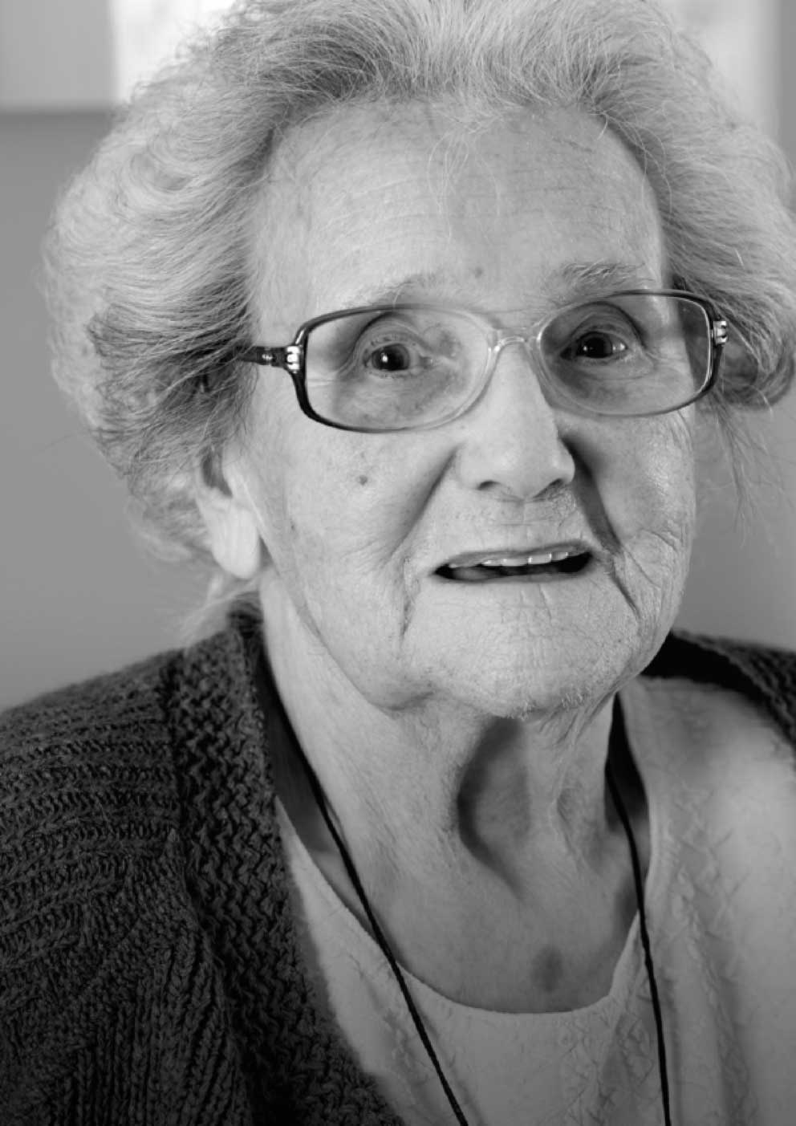
Annex 1

Terms of reference
End of Life Care Programme Board
Document filename: Terms of reference End of Life Care Programme Board
Directorate / programme | Medical Directorate:  NHS Commissioning | Programme | End of Life Care
Document reference |  | <insert>
Project manager | Louise Corson | Status | Draft
Owner | <Insert> | Version | 1.1
Author | <Insert> | Version issue date | [Publish Date]

Terms of reference

End of Life Care Programme Board

.

Document management

Revision history
Version | Date | Summary of changes
1.1 | 07/12/2016 | Governance diagram amendment, membership updates, meeting dates removed, clarity over role of Ambitions partnership in relation to the progamme and role of the members to promote work of the board.

Reviewers
This document must be reviewed by the following people:
Reviewer name | Title/responsibility | Date | Version
Jacquie White | Deputy Director, Long Term Conditions | 06/12/2016 | 1.1
Louise Corson | Programme Manager End of Life Care | 07/12/2016 | 1.1

Approved by
This document must be approved by the following people:
Name | Signature | Title | Date | Version
Bee Wee |  | National Director for End of Life Care
Sir Bruce Keogh |  | National Medical Director
Jacquie White |  | Deputy Director, Long Term Conditions

Related documents
Title | Owner | Location
NHS England Mandate 2016-17 | Department of Health | https://www.gov.uk/government/publications/nhs-mandate-2016-to-2017
Ambitions for Palliative and End of Life Care: A national framework for local action 2015-2020 | National Palliative and End of Life Care Partnership | http://endoflifecareambitions.org.uk/
Our commitment to you for End of Life Care | Department of Health | https://www.gov.uk/government/publications/choice-in-end-of-life-care-government-response

Document control
The controlled copy of this document is maintained by NHS England. Any copies of this document held outside of that area, in whatever format (e.g. paper, email attachment), are considered to have passed out of control and should be checked for currency and validity.

Contents
Document management 3
Revision history 3
Reviewers 3
Contents 5
1 Background 6
2 Aim of the End of Life Care Programme Board 6
3 Accountability 7
4 Membership 7
5 Senior responsible owner (SRO) and programme board members 8
6 Frequency of meetings 9
7 Standing agenda 10
8 Secretariat 10
9 Governance structure 10

- Background

The national End of Life Care Programme aims to deliver a number of objectives:

- Embed the Ambitions for Palliative and End of Life Care: A national framework for local action 2015-2020
- Deliver the government’s response to the ‘Choice Review’ including the six point ‘End of Life Care Commitment’
- Deliver the NHS England Mandate objective that by 2020 we should “significantly improve patient choice, including in maternity, end-of-life care and for people with long-term conditions, including ensuring an increase in the number of people able to die in the place of their choice, including at home”.

To support achievement of these objectives NHS England is proposing to lead the EoLC programme through cross-system governance, supporting commissioners and providers through three workstreams, to:

- Enhancing physical and mental well-being of the individual
- To optimise the person’s mental and physical wellbeing so that they can ‘live as well as they wish’ until they die
- To optimise support for their families, carers and those important to them to maximise their wellbeing before and after the person’s death

- Transforming experience of end of life care the community and hospitals
- To significantly improve the experience of end of life care at home, in care homes, hospitals, hospices and other institutions

- Commissioning quality services that are accessible to all when needed
- To support commissioners and service providers to design and implement models of care which promote integration and care that feels coordinated to those using, and delivering, end of life care

The work of the programme board is supported and influenced by the national ‘Ambitions Partnership for Palliative and End of Life Care’, a partnership of 27 statutory and voluntary organisations who collectively produced the ‘Ambitions framework for palliative and end of life care: National framework for local action’. The partnership is represented by two members on the board who represent the views of their members and consider how they can support the board to deliver its objectives.

- Aim of the End of Life Care Programme Board

The purpose of the End of Life Care Programme Board is to ensure and support progress against the three end of life care work streams. This includes to:

- Provide accountability, challenge and assurance of programme delivery
- Ensure coherence and a common sense of direction across the three work streams
- Identify where further work, within or across individual work streams might be needed to achieve the government’s response to the Choice Review, NHS Mandate and Ambitions for Palliative and End of Life Care: A national framework local action 2015-2020, and to commission work accordingly
- Identify synergies between individual projects and recommend changed or additional deliverables to help exploit these with programme board members and other Arm’s Length Bodies, individual project groups, voluntary sector organisations
- Identify and manage high-level risks to delivery
- Be accountable for the project’s expenditure

- Accountability

The End of Life Care Programme Board is accountable to the National Medical Director of NHS England as the SRO for this programme.
The National Medical Director will provide strategic direction and leadership to the End of Life Care Programme Board to ensure delivery of the programme outcomes and benefits in line with the objectives of the national programme.

- Membership

End of Life Care Programme Board

Name | Title | Organisation
Adrienne Betteley | Interim Head of Health & Social Care  (representative from Ambitions Partnership) | Macmillan Cancer Support
Jane Barnacle | Regional Director of Patients and Information (London Region) | NHS England
John Clark | Director and Dean of Education and Quality - South of England | Health Education England
Louise Corson | Programme Manager for End of Life Care | Medical Directorate,  NHS England
Jane Cummings | Chief Nursing Officer | Nursing Directorate, NHS England
Jonathan Ellis | Director of Policy and Advocacy | Hospice UK
Deborah El Sayed | Director of Digital and Multi Channel Development, Information & Operations Directorate | NHS England
Claire Henry | Chief Executive, Dying Matters | National Council for Palliative Care
Sam Higginson | Director of Strategic Finance, Finance Directorate | NHS England
Anthony Kealy | Head of Integration Delivery | NHS England
Sir Bruce Keogh | National Medical Director (SRO) | NHS England
Jacqueline Lansley | Director of Strategy, Commissioning & Procurement  Integrated Commissioning Team | NHS Southend Clinical Commissioning Group and Southend-on-Sea Borough Council
David Levy | Regional Medical Director -Midlands and East of England | NHS England
Jonathan Marron | Director of Community, Mental Health and Seven Day Services | Department of Health
Phil McCarvill | Deputy Director of Policy | NHS Confederation
Jacqueline McKenna | Director of Nursing - Professional Leadership | NHS Improvement
Catherine Millington-Sanders | National Clinical End of Life Care Champion  (representative from Ambitions Partnership) | RCGP
John Powell | Corporate Director of Health and Social Care Integration | ADASS
Mike Richards | Chief Inspector of Hospitals | Care Quality Commission
James Sanderson | Director of Personalisation and Choice, Commissioning Strategy | NHS England
Malcolm Senior | Programme Director for Integration and Social Care (tbc) | NHS Digital
Julia Verne | Clinical Lead - National End of Life Care Intelligence Network | Public Health England
David Warriner | End of Life Care Clinical Fellow | NHS England
Bee Wee | National Clinical Director, End of Life Care | Medical Directorate, NHS England
Jacquie White | Deputy Director, Long Term Conditions, Older People and End of Life Care Unit | NHS England
Hannah Williams | Health and Social Care Commissioning Manager – End of Life, Quality Manager – Community | Gloucestershire Clinical Commissioning Group
PPV partner | tbc | tbc

The composition of the programme board allows for members to be co-opted onto the board for specific topics under consideration, for example, urgent and emergency care, dementia and cancer.

The meeting will be quorate through attendance by 10 members, not including any deputies attending in a proxy capacity.

- Senior responsible owner (SRO) and programme board members

The National Medical Director for NHS England is the programme Senior Responsible Owner (SRO). The SRO is ultimately accountable and provides overall direction and leadership for delivery of the programme.

Programme board members will be expected to:
- Provide accountability for progress against deliverables within their organisation or represented group
- Understand high level project/programme plans and have the ability to monitor progress against them
- Understand and act on those factors that affect the successful delivery of the programme and projects within it
- Broker relationships with stakeholders within and outside the programme
- Provide delegated authority, as required, to ensure the project/programme meets its objectives
- Be aware of the broader perspective.

Programme board members will:
- Attend all scheduled steering group meetings, and only in exceptional circumstances, nominate a proxy
- Where members represent an interdependency area, to act as the conduit for awareness-raising, identification and supporting resolution of any issues arising
- Share communications and information
- Be responsible for defined acceptable risk profiles and thresholds for their individual programmes and projects
- Provide assurance for operational stability and effectiveness throughout the programme
- Understand and manage the impact of change to the programme and deliverables
- Be responsible for benefits estimating and realisation for deliverables they own
- Resolve dependencies
- Own the resolution of programme risks and issues
- Promote and communicate the work of the programme through their own networks

- Frequency of meetings

- Bi-monthly programme board meetings will be held for 2 hours by videoconference in London and Leeds
- Regular working group meetings will be held with leads for deliverables in between programme board meetings

- Standing agenda

- Welcome and apologies

- Review minutes and actions from previous meeting

- Update from workstreams
- Enhancing physical and mental well-being of the individual
- Transforming experience of end of life care in the community and hospitals
- Commissioning quality services that are accessible to all when needed

- In depth review of workstream / deliverables / subject X

- AOB

- Future meetings

- Secretariat

The Secretariat function will be provided by the Long Term Conditions, Older People and End of Life Care unit, this includes:
- Preparing and providing agenda and supporting papers
- Preparing meeting notes and information
- Agenda items will be agreed at the end of the previous meeting. Papers must be submitted no later than 14 days in advance of the meeting.
Meeting agenda, action notes and papers will be provided to members 5 days before the meeting.

- Governance structure

This structure lists the groups in place underneath the EoLC programme board, some of which are ‘task and finish’ groups:
Individual organisation’s governance routes

Programme Management Support
End of Life Care Programme Board

EoLC
Digital Delivery Group
Independent Care Sector Steering Group

Individual project
reporting

EoLC metrics working group
EoLC hospital / community oversight group (tbc)

Workstream 1: Enhancing physical and mental well-being of the individual

Workstream 2: Transforming experience of end of life care in the community & hospitals

Workstream 3: Commissioning quality services that are accessible to all when needed

